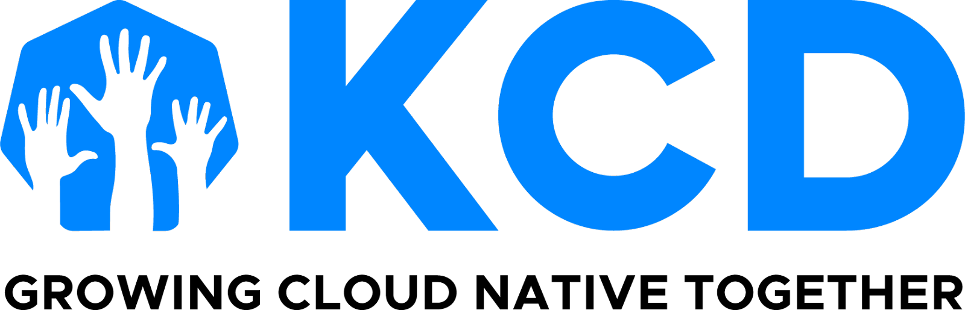

KCD Monthly Organizer Digest

December 20, 2024

As the end of the year approaches, I reflect on the 35 in-person and virtual KCDs produced and look forward to what has yet to come. I want to thank each and every one of you for helping make this program what it is today. The quality events you bring to your local communities, in a CNCF-like fashion, help make the KCD brand strong.

**Looking to 2025**

Next year will be the Cloud Native Computing Foundation's 10th anniversary, so keep your eyes and/or ears open for all the fun surrounding it! 🎉

RECENT KCDs

## **Congratulations, Austria, Chattogram, MENA, UK, Denmark, Accra, Indonesia, and Floripa!**

Eight KCDs were hosted in the final months of the year, two of which were virtual. Congratulations to those teams for their hard work and dedication to making events full of cloud native learning, mindshare, and networking!

NEWS

## **2025 KCDs Are Under Way!**

If you have not yet seen - have a look at which KCDs have their [Call for Proposals](https://sessionize.com/2025-kcd-open-call-for-proposals/) and [Sponsorships](https://github.com/cncf/kubernetes-community-days/tree/main/sponsor-resources/open-prospectuses) open!

If your team has either your CFP or prospectus ready, and they are not on the above lists, please contact Audra to have them added.

Starting January, 2025 organizers will officially be subscribed to this KCD global newsletter (now on bcc). Please note: 2024 organizers not producing an event in 2025 will automatically be removed from the subscription.

LEARNING

## **Last Week’s KCD Interest Group: Bevy Pay + Page Builder**

In case you missed last Wednesday’s demo by Bevy Experts, [the recording can be found on YouTube here](https://youtu.be/NLr1w3Lfoh8?si=QNzGk3ykzKSp8Tdq).

Also [here is a Bevy presentation on Bevy Pay](https://docs.google.com/presentation/d/1eSqF3FMkwqU1_SghI5AGOL5uN2MtYqVIgbkZ377AisY/edit?usp=sharing), and as always, you can get more up-to-date help [via their help center.](https://help.bevy.com/hc/en-us/articles/25841575242263-Chapter-Level-Payouts#h_01J5XTFNHNA7BQY0267GDVXJBY)

OPPORTUNITY

## **KubeCon + CloudNativeCon London 2025**

The KubeCon + CloudNativeCon London discounts are here! While Early Bird pricing is over, this 50% off standard pricing saves you $110 USD!

* KCEU25O50KCD 50% - KCD Organizer (not to be shared outside of your KCD org team)
* KCEU25O15SHR 15% - KCD Organizer Shareable discount for KCD attendees

| [**Register**](https://events.linuxfoundation.org/kubecon-cloudnativecon-europe/register/) |
| --- |

## **CNCF Refresh**

CNCF will have an end-of-year refresh during holiday time, from December 23 to January 2. I will personally be back on January 3, mainly catching up on email and Slack. I wish you and your families some quality time together and much-deserved rest for yourself.

As always, thank you for helping make cloud native ubiquitous in your spare time!

**Audra Montenegro | audra@cncf.io**

**CNCF Community Program Manager**

**US Time zone: Pacific**

**KCD** [**GitHub Repository**](https://github.com/cncf/kubernetes-community-days/blob/main/README.md)

**KCDs on​ Social Media |** [**LinkedIn ​**](https://www.linkedin.com/company/kcds-by-cncf/)**|** [**X/Twitter**](https://twitter.com/KubernetesDays)